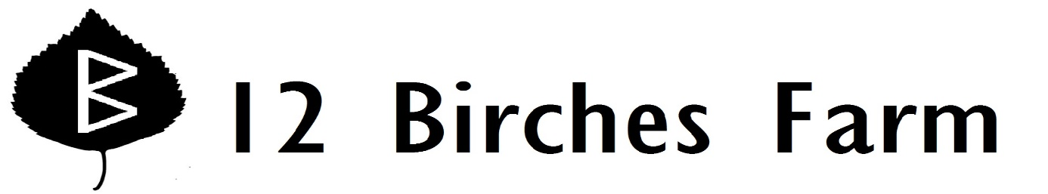

Week 6
Carrots
Snow Peas
Cucumber!
Garlic Scapes
Chinese Cabbage
Bok Choi
Lettuce-- a leaf lettuce called Salad Bowl
Red Russian Kale
Strawberries!

Farm news: Your cucumbers are parthenocarpic—that means they don’t need to be pollinated to produce fruit, and they’ll never make seeds—and that they fruit several weeks earlier than the rest of the cucumbers I’ve planted. The two parthenocarpic varieties are Manny, which I’ve grown before, and Adam, a new one, which seems to be even earlier. They are hybrid seeds (that is the only way to get parthenocarpic seeds), more expensive than the open pollinated varieties, but worth it, I think, for early seedless cukes with tender skins. Later in the year, we’ll have Marketmore cukes—an old tried and true variety—as well as the fun ones: Silver Slicer, Lemon, and Richmond Green Apple.

SNOW PEA AND NAPA CABBAGE SLAW modified from GOURMET SEPTEMBER 1995
Mix together:
1/2 pound snow peas, de-stemmed and strings discarded, sliced thin diagonally
1 Napa cabbage, cut into thin shreds
4 carrots, shredded
½ bunch garlic scapes, chopped finely and sautéed in olive oil
1 tablespoon lemon juice
1 tablespoon rice vinegar
3 tablespoons olive oil
Salt and pepper to taste

KALE AND TOASTED WALNUTS
1 bunch kale, rinsed, stems and all, chopped finely
1/2 cup chopped walnuts
1 tablespoons olive oil
½ bunch garlic scapes, chopped finely
Salt and pepper to taste
Cook walnuts in oil in a 12-inch heavy skillet over medium-low heat, stirring occasionally, until pale golden, about 5 minutes. Stir in garlic scapes and cook, stirring, until very fragrant, about 1 minute. Add kale and salt and pepper to taste and cook, tossing, until kale turns bright green and tender (if your pan seems too dry, add a tablespoon of water to help wilt the kale).

